## 5656

# Experiment #7: Series & Parallel Resonance

Christopher Badolato

Yajaira Varillas Perez

EEL3123C-0013

3/20/2019

## Objectives

## To study the behavior of series and parallel LC circuits at resonance.

## To understand the resonance frequency, cut-off frequency, bandwidth and quality factor of a resonance circuit.

## To determine if a circuit is inductive or capacitive.

## To understand the circuit behavior at resonance.

## Equipment

## Breadboard

## Circuitry components

## Function generator

## Oscilloscope

Circuits

Image taken directly from lab report:

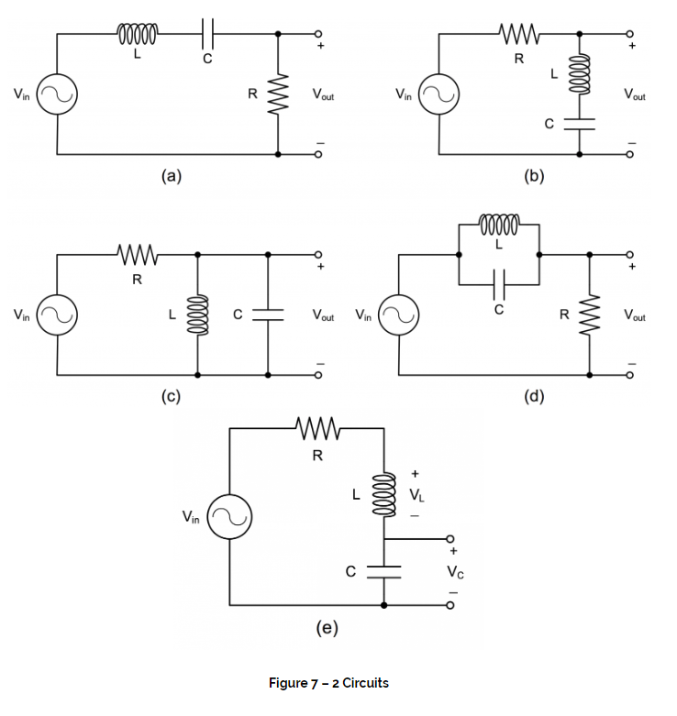

Simulations

|  |
| --- |
| Circuits A,B,C,D:  The simulations on the next pages, we are measuring our resonance frequency at our Vmax for bandpass filters  for band reject filters.  At -3 decibels, we can locate our resonance frequencies.  At these values, we can find out resonance frequency as well as our cutoff voltage to find our cutoff frequencies.  bandpass:  Or bandreject:  The results are similar to our preparation and our measurements except for Circuit B and Circuit D where our measurements are largely different than the results in our simulation. I’m not sure if we were measuring the bandreject filters correctly on the multisim. We measured at -3db.  Circuit E  We find the magnitude of the voltage of |

|  |
| --- |
| Circuit A  Circuit A resonance frequency = 1.5849 kHz  At -3 db:  Frequency cutoff upper = 2.5816 kHz  Frequency cutoff lower = 982.7260 kHz  Bandwidth = 2581.6 - 982.7260  Bandwidth = 1598.874 Hz  =  = 0.9687 |

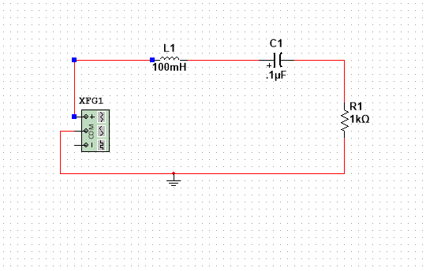

|  |
| --- |
| Circuit A resonance frequency:  1.5849 kHz |

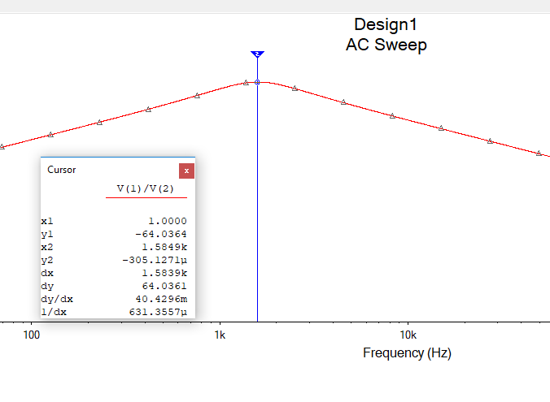

|  |
| --- |
| Circuit A upper cutoff:  2.5816k Hz |

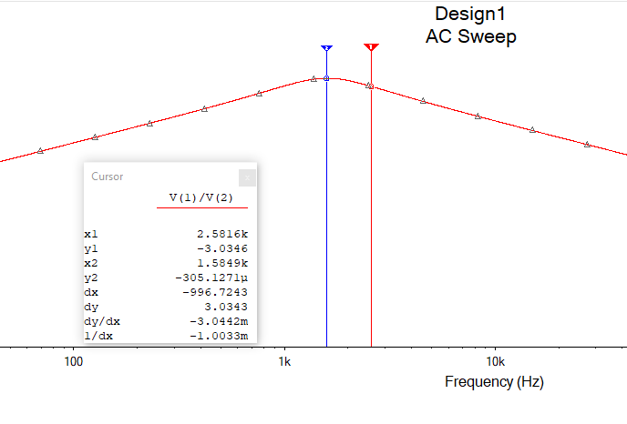

|  |
| --- |
| Circuit A lower cutoff:  982.7260 Hz |

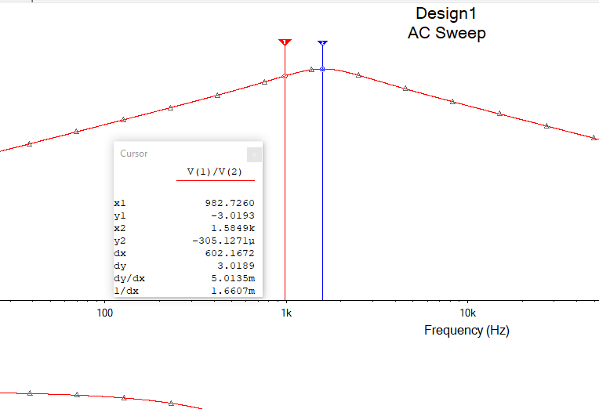

|  |
| --- |
| Circuit B  Circuit B resonance frequency = 1.5933k Hz  At -3 db:  Frequency cutoff upper = 2.5654 kHz  Frequency cutoff lower = 982.2729 kHz  Bandwidth = 2.5654 - 982.2729  Bandwidth = 979.707 Hz  =  = 1.626k Hz  These values match our calculated values in the preparation but differ a bit from our measured values. |

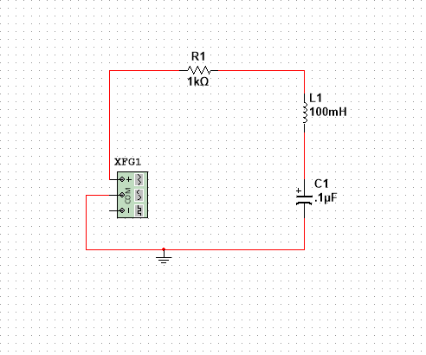

|  |
| --- |
| Circuit B resonance:  1.5933k Hz |

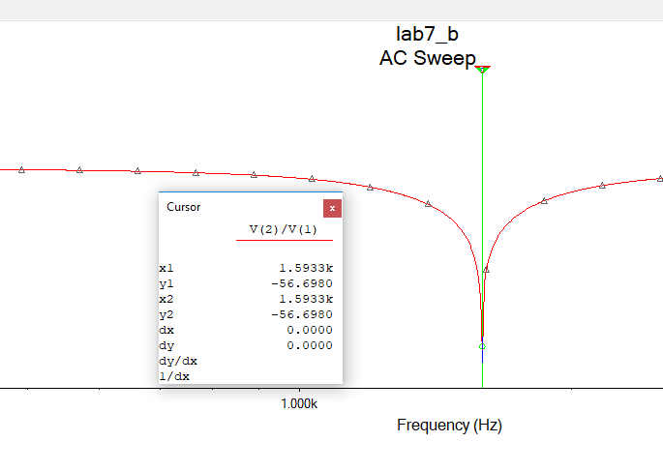

|  |
| --- |
| Circuit B upper cutoff:  2.5654 kHz |

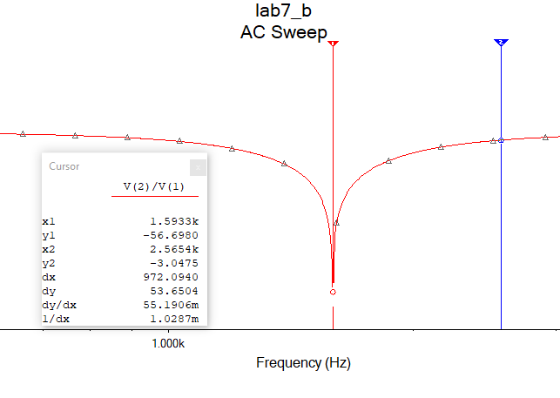

|  |
| --- |
| Circuit B lower cutoff:  982.2729 Hz |

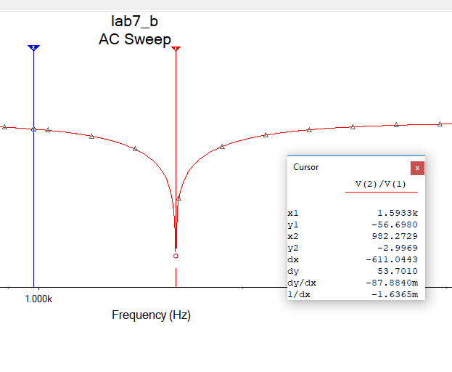

|  |
| --- |
| Circuit C  Circuit C resonance frequency = 1.6008 kHz  At -3 db:  Frequency cutoff upper = 2.5816 kHz  Frequency cutoff lower = 982.726 kHz  Bandwidth = 2581.6- 982.726  Bandwidth = 1598.874 Hz  =  = 1.0012 |

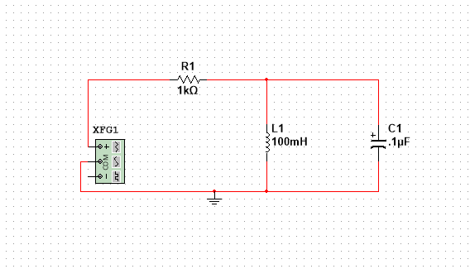

|  |
| --- |
| Circuit C resonance:  1.6008 kHz |

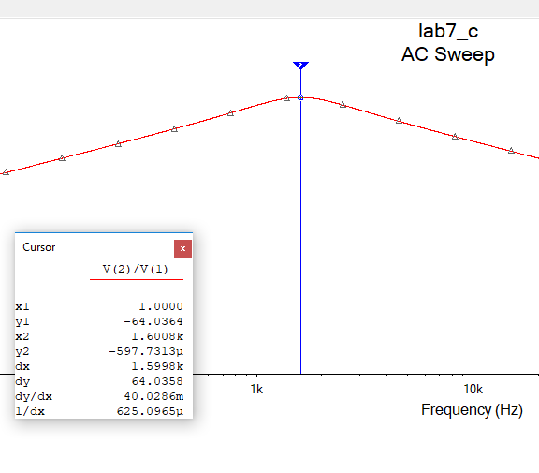

|  |
| --- |
| Circuit C upper cutoff:  2.5816 kHz |

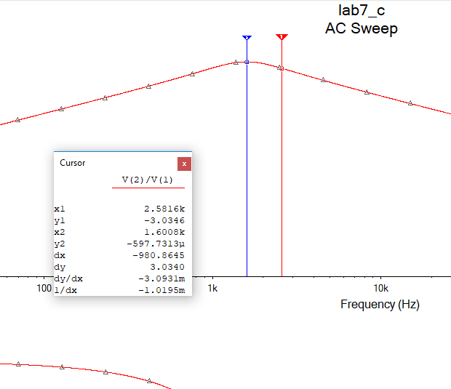

|  |
| --- |
| Circuit C lower cutoff  982.7260 kHz |

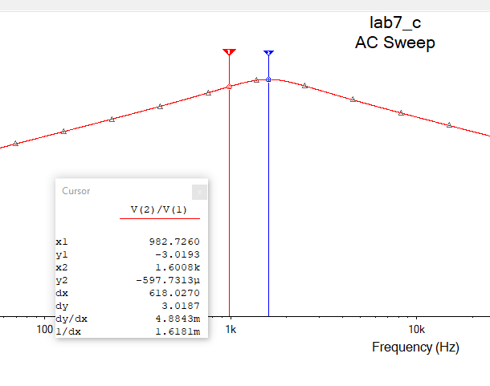

|  |
| --- |
| Circuit D  Circuit D resonance = 1.5914 kHz  At -3 db:  Frequency cutoff upper = 2.5756 kHz  Frequency cutoff lower = 982.9576 kHz  Bandwidth = 25756 - 982.9576  Bandwidth = 1592.6424 Hz  =  = 1.20177  These values varied from my measure and calculated more than expected. |

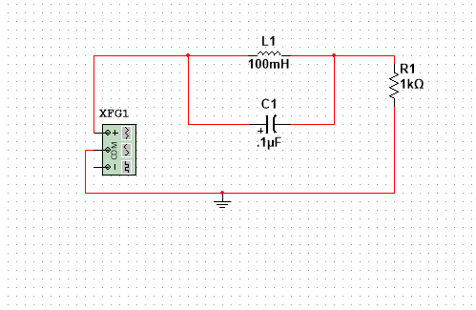

|  |
| --- |
| Circuit D resonance:  1.5914 kHz |

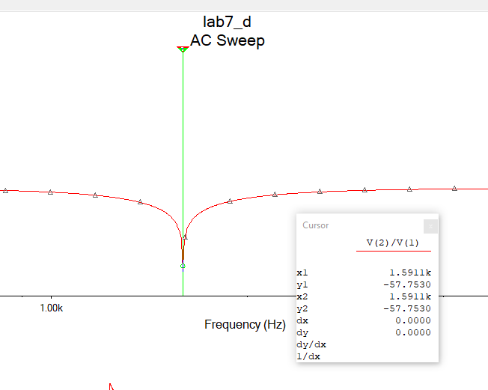

|  |
| --- |
| Circuit D upper cutoff:  2.5756 kHz |

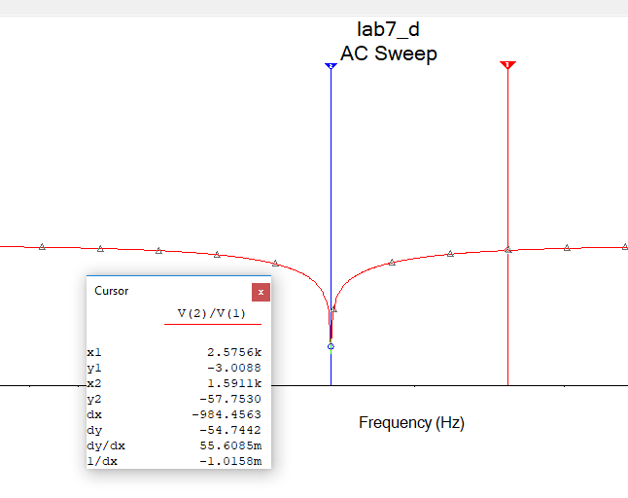

|  |
| --- |
| Circuit D lower cutoff:  982.9576 Hz |

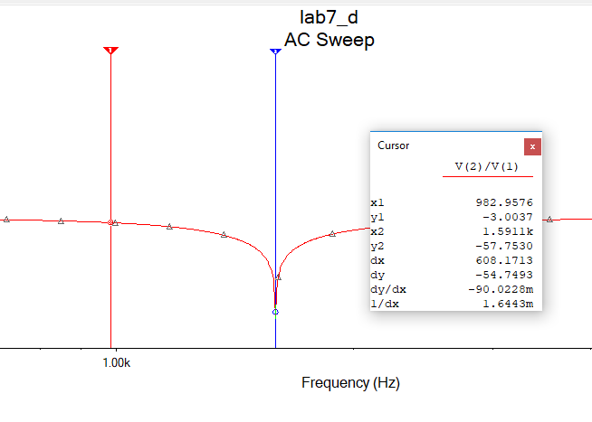

|  |
| --- |
| Circuit E  with a 300 Ω resistor |

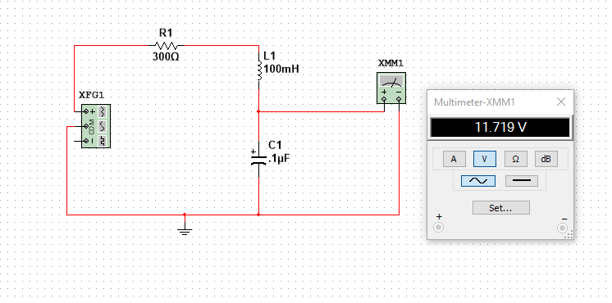

|  |
| --- |
| with a 3000 Ω resistor |

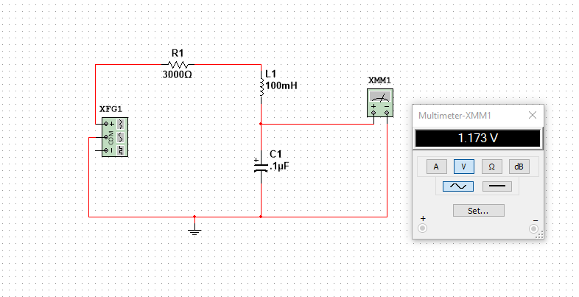

Experiment

|  |
| --- |
| **Questions 1-7**  For each circuit below we measured the resonance frequency at the Vmax or Vmin.  Using the Vmax we found our cutoff voltages.  Each Circuit contains 3 images, resonance frequency, upper cutoff frequency and lower cutoff frequency measured at the .  Or  Using the cutoff frequencies, found at these cutoff voltages, we can find calculate the bandwidth for bandpass or band reject filters.  Bandwidth = Upper cutoff Frequency - Lower cutoff Frequency  Finally using our bandwidth we can calculate the (quality factor) of the circuit. is also define as an energy Ratio.  We use: |

|  |
| --- |
| Circuit A  Circuit A resonance frequency = 1.59093k Hz  Measured maximum voltage = 4.32V  = 3.05470V  Frequency cutoff upper = 2.893 kHz  Frequency cutoff lower = 981.225 kHz  Bandwidth = 2983 - 981.225  Bandwidth = 2001.775 Hz  =  = 0.7948  The values taken in measurements are slightly off from our calculated and simulated values. |

|  |
| --- |
| Circuit A resonance frequency = 1.59093 kHz |

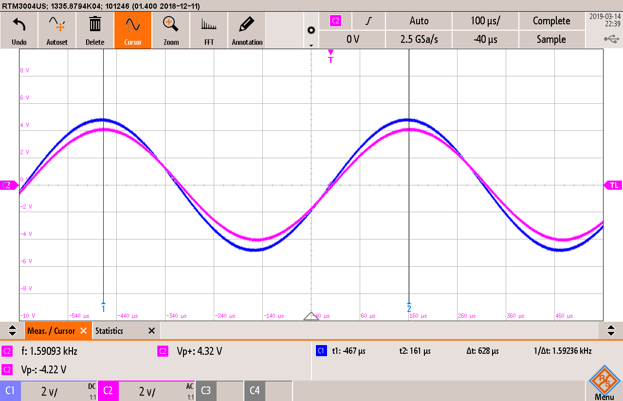

|  |
| --- |
| Circuit A  Upper cutoff Frequency:  At our calculated voltage of 3.05470 Circuit A measured upper cutoff frequency is  2.89333 kHz |

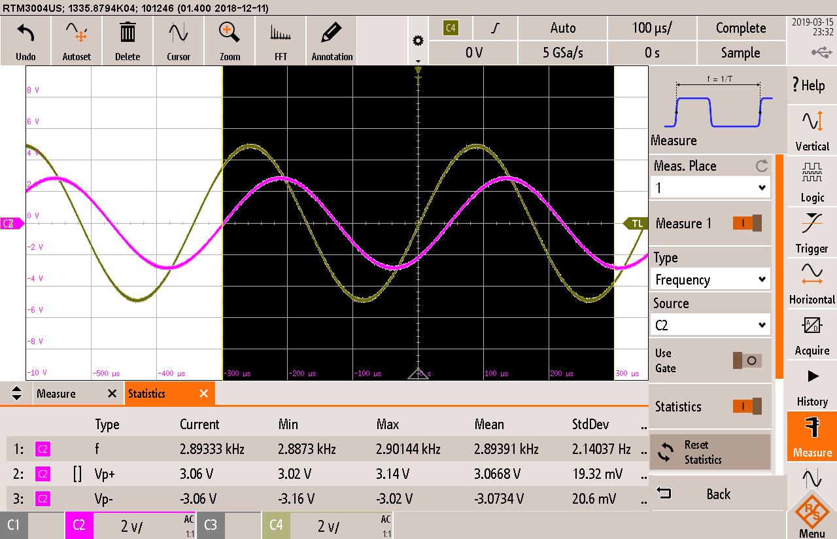

|  |
| --- |
| Circuit A  Lower cutoff Frequency  At our calculated voltage of 3.05470 Circuit A measured lower cutoff frequency is  981.225 Hz  The values calculated in our preparation are similar. |

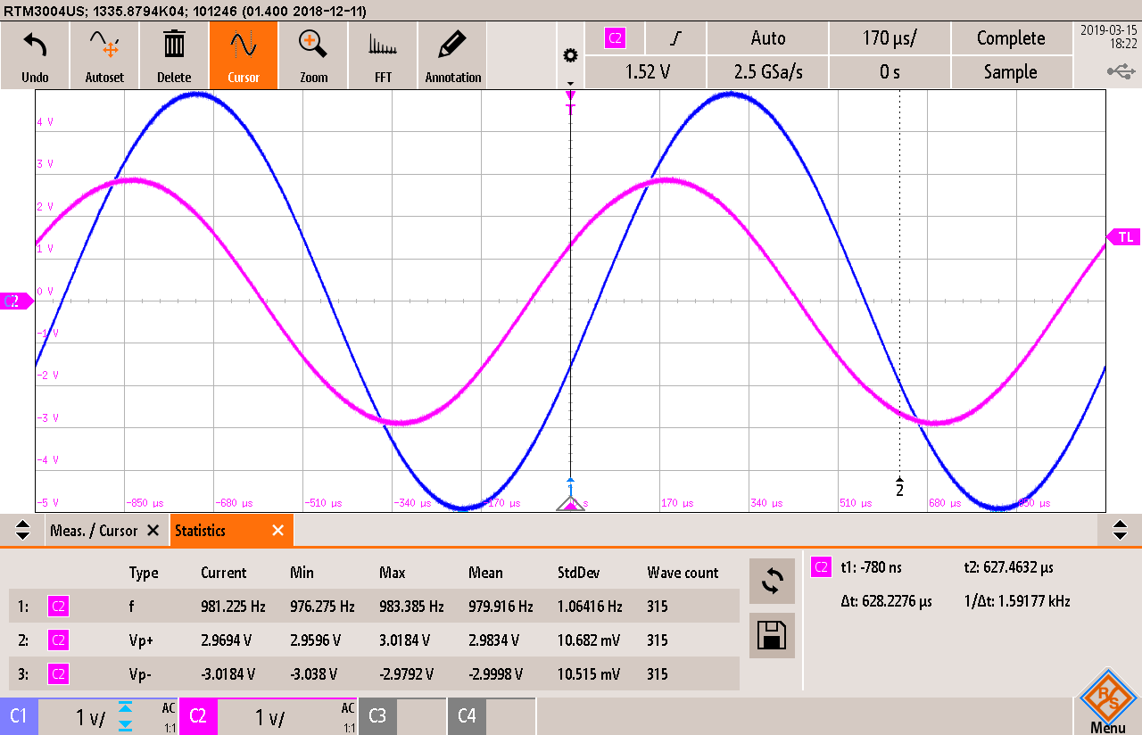

|  |
| --- |
| Circuit B  Circuit B resonance = 1.50353 kHz  Measured minimum voltage = 840V  = 1.1313V  Frequency cutoff upper = 1.68 kHz  Frequency cutoff lower = 1.34 kHz  Bandwidth = 1.68 - 1.34  Bandwidth = 0.34 kHz  =  = 4.422 |

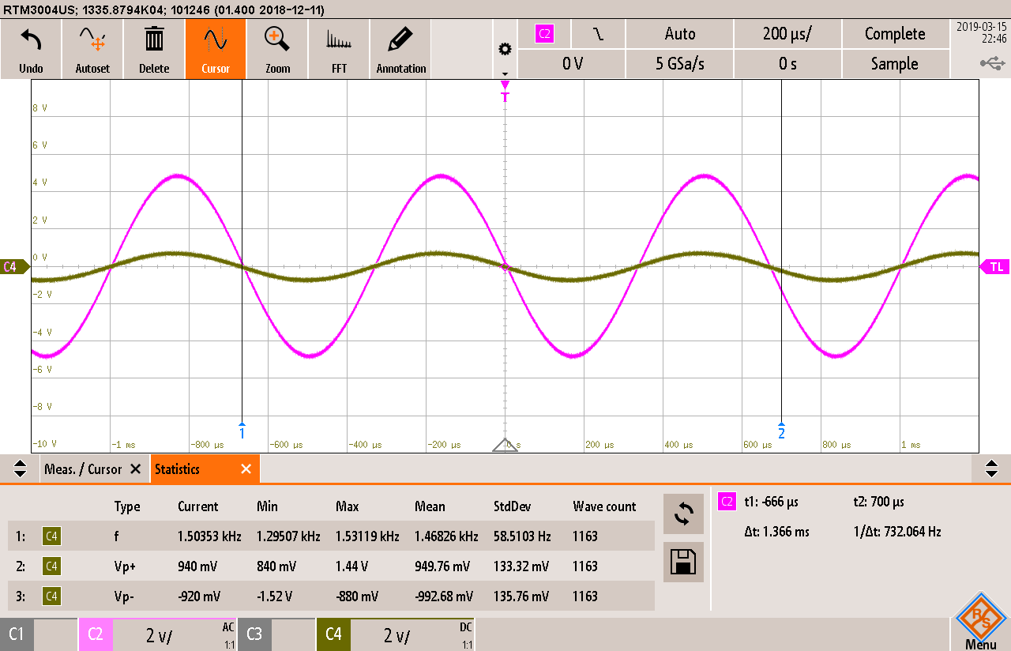

|  |
| --- |
| Circuit B  Ended up missing a photo of Circuit B upper cutoff and didn’t have time to make it back to the after hours lab again, our measured upper frequency was  1.68 kHz |

|  |
| --- |
| Circuit B  Lower cutoff Frequency:  At our calculated voltage of Circuit A measured lower cutoff frequency is  1.34 kHz |

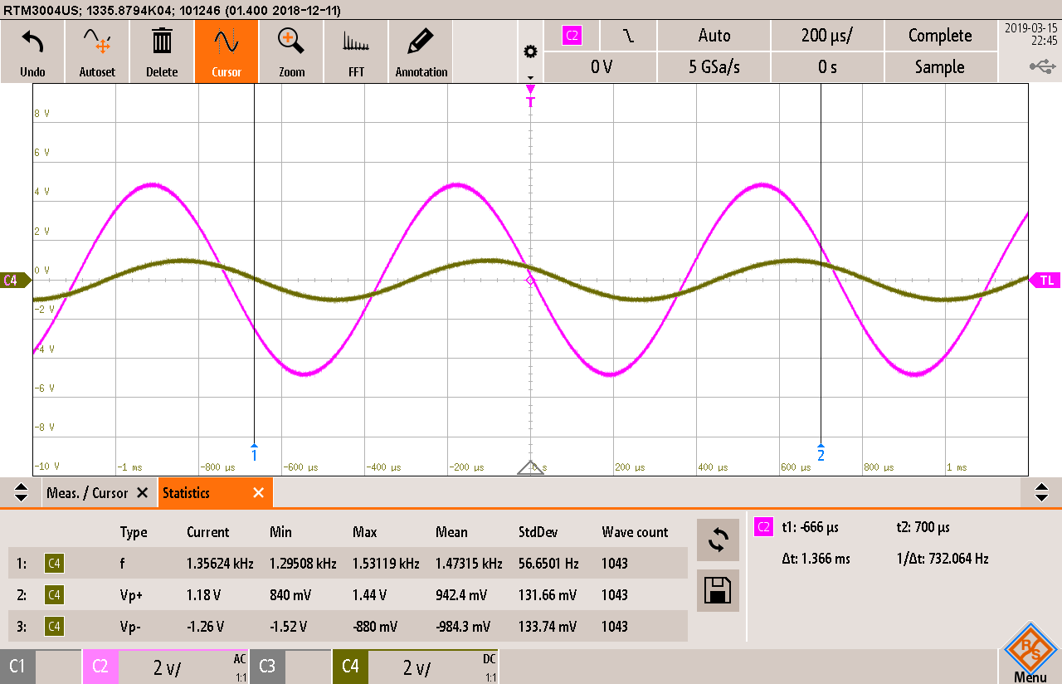

|  |
| --- |
| Circuit C  Circuit C resonance = 1.648 Hz  Measured maximum voltage = 4.48V  = 3.17 V  Frequency cutoff upper = 2.57954 kHz  Frequency cutoff lower = 938.952 Hz  Bandwidth = 2579.54Hz - 938.952Hz  Bandwidth = 1640.588 k Hz  =  = 1.0045 |

|  |
| --- |
| Circuit C resonance frequency = 1.648 kHz |

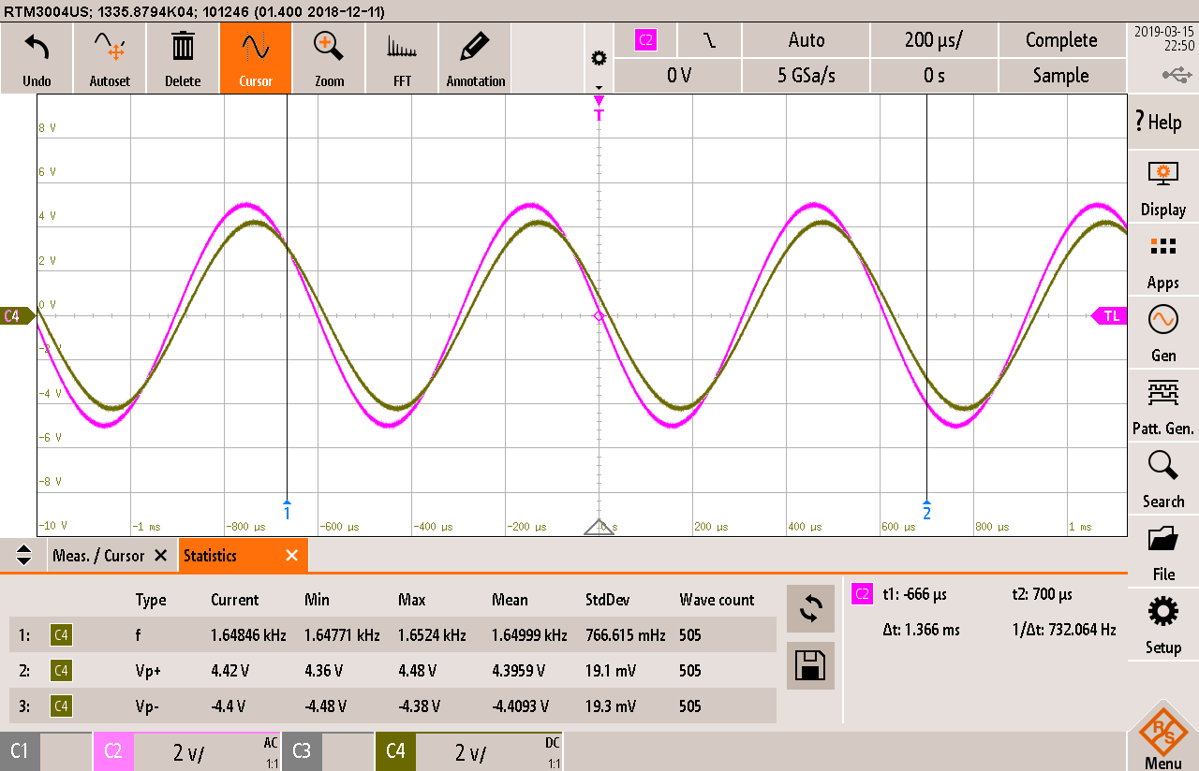

|  |
| --- |
| Circuit C  Upper cutoff Frequency:  At approximately 3.17V  2.57904 kHz |

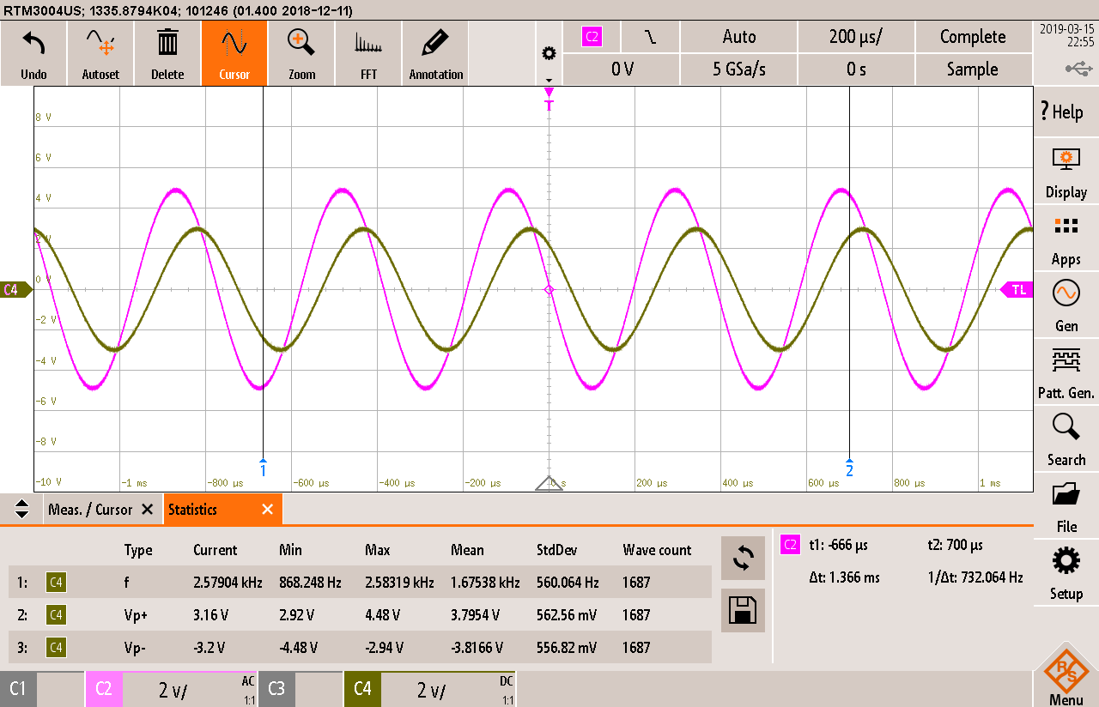

|  |
| --- |
| Circuit C  Lower cutoff Frequency  At approximately 3.17V  938.952 k Hz |

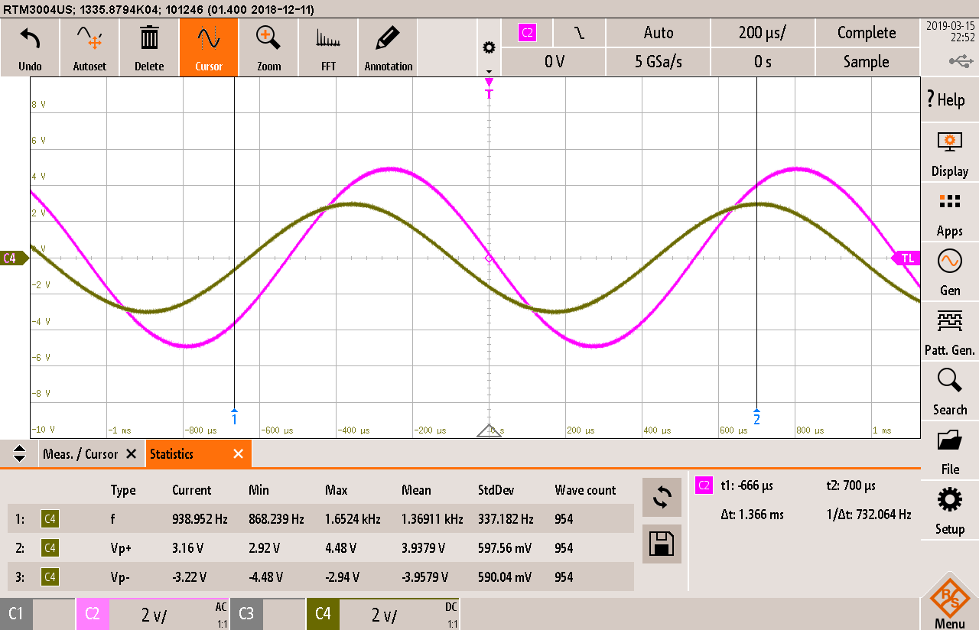

|  |
| --- |
| Circuit D  Circuit D resonance frequency = 1.463 Hz  Measured maximum voltage = 0.920V  = 1.356V  Frequency cutoff upper = 1.3513 kHz  Frequency cutoff lower = 1.6341 Hz  Bandwidth = 1.3513Hz - 1.63412Hz  Bandwidth = 0.28282 kHz  =  = 5.1729 |

|  |
| --- |
| Circuit D resonance frequency = 1.463 kHz |

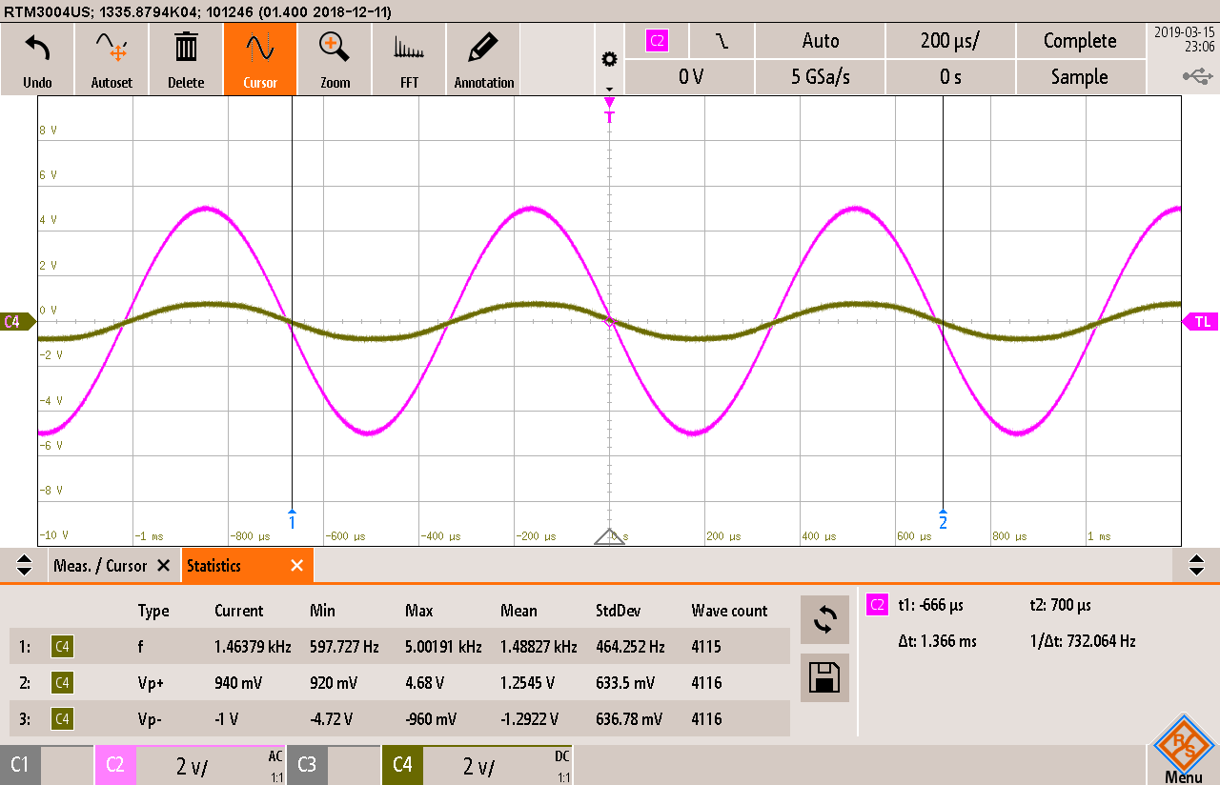

|  |
| --- |
| Circuit D  Upper cutoff Frequency:  At approximately 1.356V  1.634 kHz |

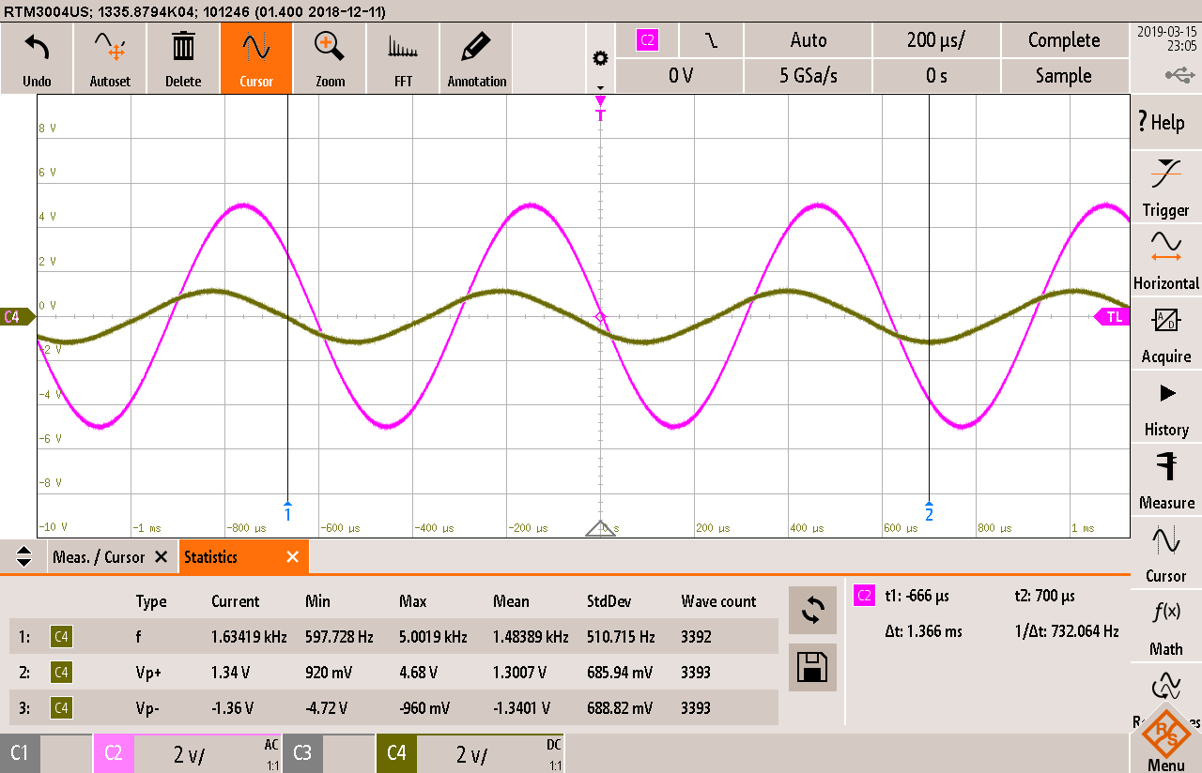

|  |
| --- |
| Circuit D  Lower cutoff Frequency:  At approximately 1.356V  1.3566 kHz |

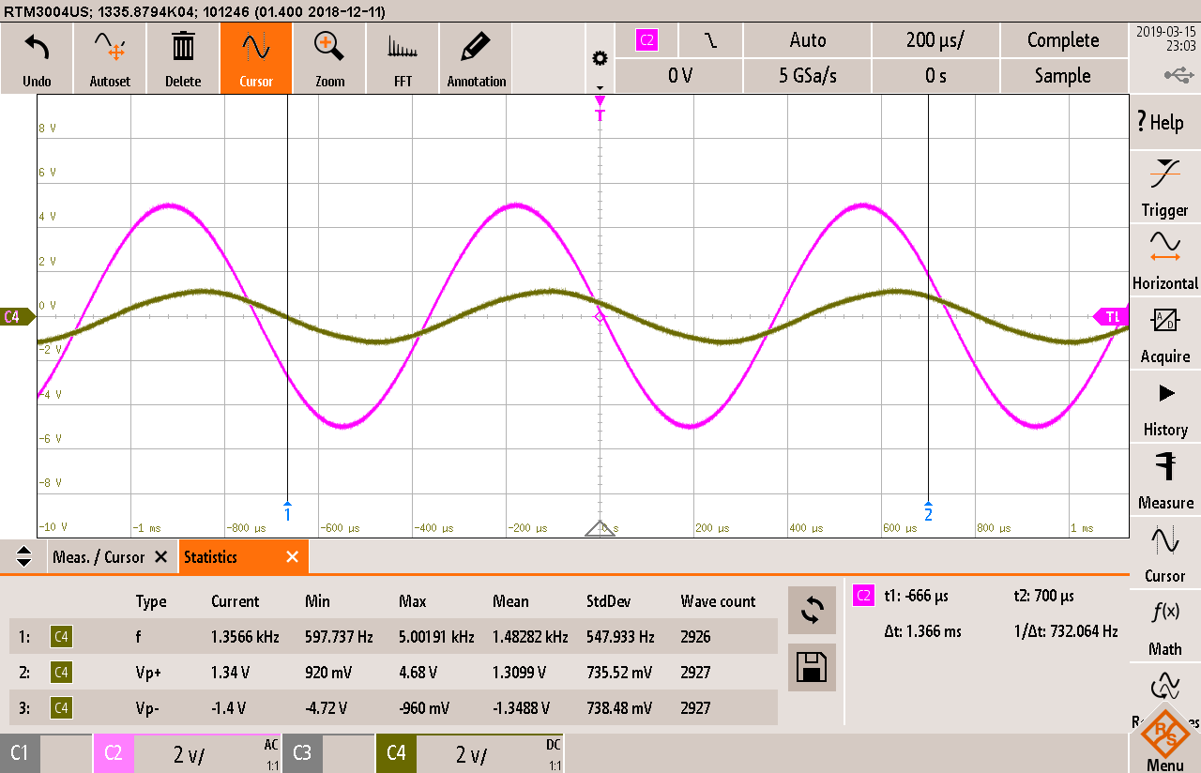

|  |
| --- |
| **Questions 8-9**  Find the magnitude for VC for the following cases.  R = 3 kΩ,  R = 300 Ω. |

|  |
| --- |
| 3000Ω  Input voltage of  5V  Frequency = 1.50353 kHz (from circuit b resonance)  The magnitude of the output voltage Vc with a 3000 resistor is  = 10.633V |

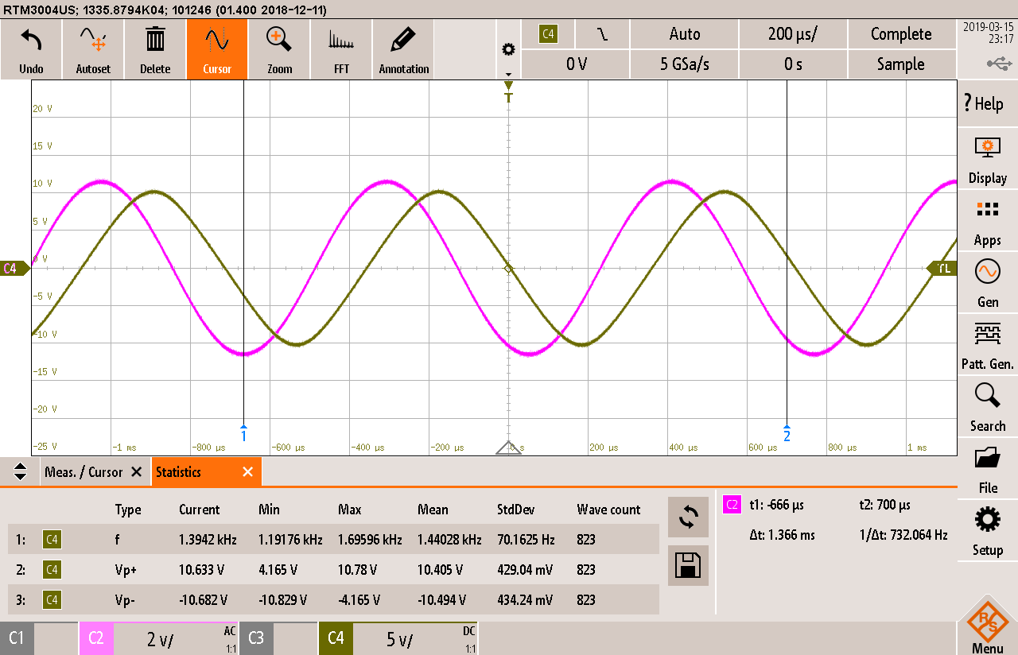

|  |
| --- |
| 300Ω  Input voltage of 5V  Frequency = 1.50353 kHz (from circuit b resonance)  The magnitude of the output voltage Vc with a 300 resistor is  = 1.74V |

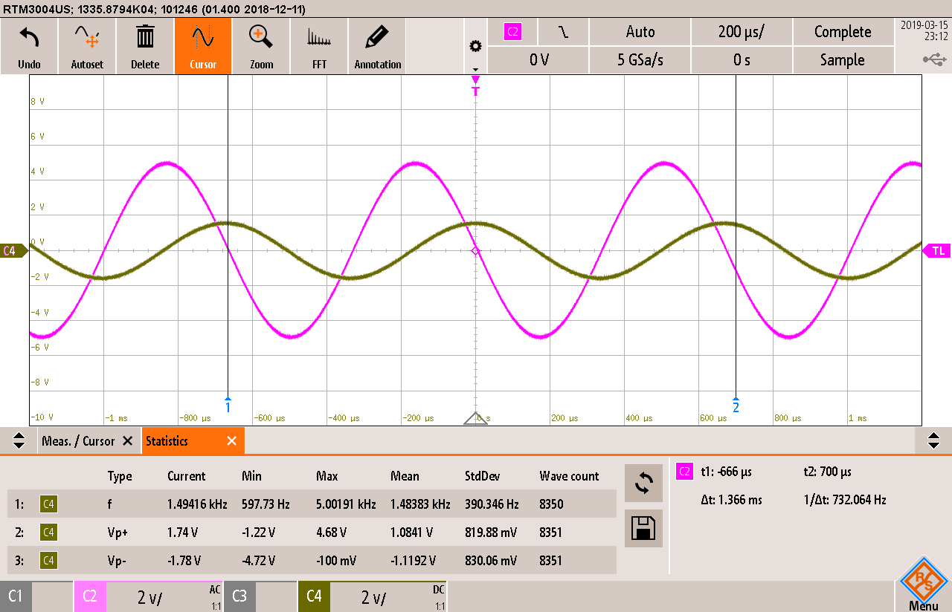

Conclusion

In conclusion, within this lab, for our resonant circuits (form the basis for filters) we found the resonance frequency for each circuit at our (for bandpass) and (for bandreject). Using these voltages, we can calculate our cutoff Voltage. If you go to this cutoff voltage, the half-power frequency located at this voltage is our cutoff frequency. We have an upper cutoff and lower cutoff frequency. Cutoff frequencies will be used to calculate the by first calculating the bandwidth. Bandwidth is our upper cutoff frequency minus the lower cutoff frequency. We can then divide our calculated bandwidth by the found resonance frequency giving us the Q factor. This Q factor is a ratio of maximum energy stored over total energy lost per period.